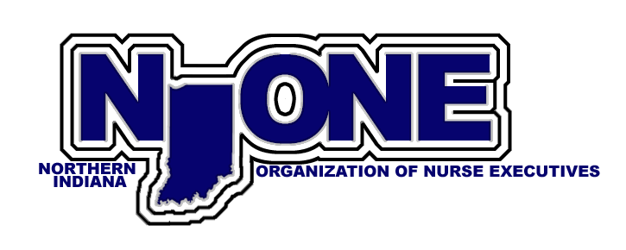

NIONE 2019 Annual Report:

The Northern District of IONE held the following meetings this past year:

February 26, 2019
This meeting was held at Franciscan Hospital in Michigan City. Seven members were in attendance. Round table introductions took place. Discussion on the topic membership would like to discuss this coming year, guest speaks, and opportunities we can support. We also discussed where to hold upcoming meetings. Members were then treated to a tour of the new hospital.
April 23, 2019
This meeting was held at the Purdue Northwest Portage facility. Six members were present and four via telephone. We had a guest speaker, Jeff Barton, Pharmacist and owner of Custom Dosing. Jeff gave a presentation on CBD Oils. Many questions and discussion followed. A short meeting after the presentation discussed the upcoming Fall Conference in French Lick. Possible upcoming meeting topics where also discussed.
July 23, 2019
This meeting was held at St. Mary’s Hospital in Hobart. Five were in attendance plus Mary Browning doing a short presentation via ZOOM. Mary’s presentation included advocacy experience and impressive license plate fund accumulation/disbursements. Next we had a guest speaker, Sierra Vaughn, from the Bowen Center who presented us with NW Indiana Healthcare Workforce data. Power Points we also sent out to all members.
We also discussed the possibility of having to find a replacement for our secretary/treasurer.
October 1, 2019
This meeting was held on the Purdue University Northwest Hammond Campus. We had three members in attendance and two via Zoom. Mary gave us a report on the current Legislation down State. She discusses that 200 had already registered for the Fall Conference and over 40 for the pre-conference for the Certified Nurse Leader course. She discussed Bylaw changes, and that we had 10 grant applications submitted with $150,000 budget to disperse.
New logo for NIONE will be on agenda for this next year. Along with member engagement and outreach to the new CNO’s in our area.
October 16-18, 2019 IONE Fall Conference in French Lick, IN
December 3, 2019
NIONE Christmas Party – Location TBD

2019 Current NIONE Officers:
President: Sandra Behrens, NW Indiana Area Health Education Center
President Elect: Rachel Moody, Franciscan Alliance
Interim Treasurer/Secretary: Marta Makielski

Current bank balance - $5,630.69

Respectfully submitted,

Sandy Behrens, MBA, RN
NIONE President 2019-2020

