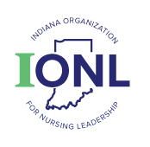 | Public Relations Committee Report  Annual Meeting 2021

In 2021 the IONL Public Relations committee activity consisted of reviewing and providing input on the Fall Conference program prior to publication, committee chair attending and participating in the IONL Board retreat and quarterly meetings and remaining available for any PR functions assigned by the IONL executive director or IONL board.

Respectfully Submitted,
Lynn Turner
IONL Public Relations Chair

